System Date & Time: 1/16/2019 at 10:53pm

Host Name: PC-Helen

OS: Microsoft Windows

IP: 172.16.0.34

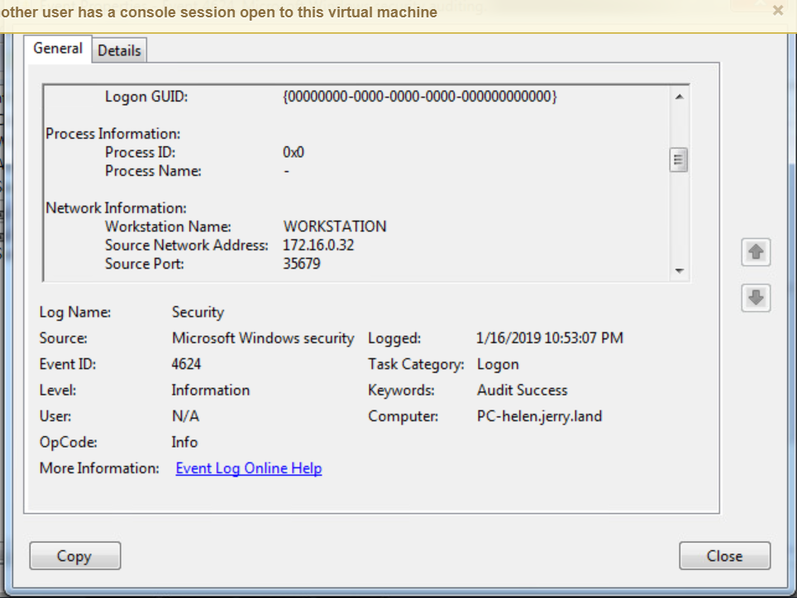

Machine name Helen was accessed through the network without credentials.

The logs indicated that an unknown net address successfully gained access.

The ip address as shown has been blacklisted in the firewall to prevent further access from this machine.